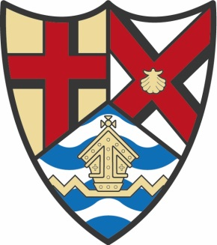

FELIXSTOWE TOWN COUNCIL
MAYOR’S ENGAGEMENT FORM

If you would like the presence of the Mayor at your event, please complete both sides of this form and return it as soon as possible to: The Mayor’s Secretary, Lorna Monsen, Felixstowe Town Council, Town Hall, Felixstowe IP11 2AG or by email to Lorna.Monsen@felixstowe.gov.uk

Please do not hesitate to contact the Mayor’s Secretary on 01394 288193 for further assistance.

Please complete as comprehensively as possible in Block Capitals.
Day and Date of Event:

Title of Event (e.g. annual dinner):

Name of Organisation:

Time Event Finishes:
Time Event Commences:

Time Appropriate for the Mayor to take their leave:
Requested Arrival Time of the Mayor:

Venue:

Venue Address and Contact Details:

Please give details if refreshments are to be provided (Attach menu if applicable):

Is there Reserved Parking for the Mayor, if so, please give details:

Purpose of Event (e.g. to fundraise for a Charity):

Are Mayoral Chains or Badge of Office to be worn ?

Dress Code:

Name of Person to Receive the Mayor, Contact & Email details:

Name of Person in Charge (if different from above), Contact & Email details:

Details of any Duties to be performed by the Mayor (e.g. Speech or Presentation):

Please Supply Information for Speech (if applicable) and relevant Background Information regarding Organisation:

Have the Press been Notified of this Event ?

Thank you !

