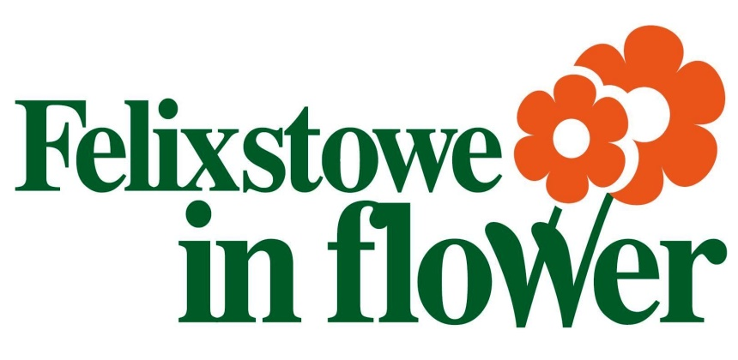

Blooming since 1985!

SPONSORSHIP FORM

I would like to sponsor ........... (Number) Floral Hanging Basket(s) at a cost of £50.00 (£30.00 for each additional basket sponsored)

I would like to sponsor ........... (Number) Flower Tubs/Troughs at a cost of £65.00 each.

Costs are inclusive of VAT and cover the purchase, installation, maintenance and watering of your displays plus a sponsor’s name plaque indicating your support.

SPONSOR’S NAME FOR LABEL/PUBLICITY ..............................................................................................
(Please write in block capitals exactly as you would like the plaque to read)

I enclose the full payment of £.......................

Signature.......................................................................................

All sponsors are acknowledged at the Felixstowe in Flower launch at the Triangle on Saturday 23 June on our ‘wall of fame’ to thank them for taking part in bringing colour to our lovely seaside town.

Name (Block Capitals) ......................................................................................

Address .............................................................................................................

...........................................................................................................................

………………………………………………….Date…………………………….

We prefer payment by bank transfer, our bank details are:
Sort code 20-98-07 Account number 40380687 – Please quote your name/Business as a reference.
Payment can also be made by cheque payable to ‘Felixstowe Town Council’
or by debit/credit card either on the telephone 01394 282086 or at the Town Hall

Felixstowe Town Council
Town Hall
Felixstowe
IP11 2AG

For more information:
01394 282086
FAX 01394 285920

Email sue.faversham@felixstowe.gov.uk

Please turn over for our Free Entry Competitions

We want you to join in by entering one of our **FREE** Felixstowe in Flower competitions!

Each competition is easy to enter, with trophies and prizes presented to winners at our illustrious Felixstowe in Flower Awards Evening.

I wish to help make Felixstowe beautiful by entering the following competition(s):
(Please all appropriate boxes)

Residential Competitions:
□ Private Front Garden – Overall best floral container, window box, hanging basket or tub.
□ Private Front Garden – Smaller gardens under 60 square metres.
□ Private Front Garden – Larger gardens over 60 square metres.
□ Town Centre – Best floral container, window box, hanging basket or tub.
□ Floral Balcony

Commercial Competitions:
□ Commercial Premises (Garden)
□ Commercial Premises (Non-Garden)
□ Commercial Premises – Overall best floral container, window box, hanging basket or tub.
□ Residential Home - Overall best floral container, window box, hanging basket or tub.
□ Hotel/Guest House - Overall best floral container, window box, hanging basket or tub.
□ Public House - Overall best floral container, window box, hanging basket or tub.

Open to all:
□ Most Unusual Container
□ Best Use of Colour
□ Best Sustainable Planting
□ Seaside theme

Children’s Competition:
□ Tallest Sunflower Competition - Grown by any person under 16 years of age.

All judging will take place in July (except tallest sunflower late August).
To enter the competition, please return this form by the end of June.

Name…………………………………………………………………………………

Address……………………………………………………………………...………

………………………………………………….Date……………………………

To find out more and get involved contact:
Felixstowe Town Council, Town Hall, Felixstowe, Suffolk IP11 2AG
01394 288191 Fax 01394 285920
Email sue.faversham@felixstowe.gov.uk or visit www.felixstowe.gov.uk
Follow us on twitter: Find us on facebook:

