The BASIC Life Charity operate two traditional charity shops in the town.
In addition we provide affordable food and other essential items at our Pop-Up shops which are held three times a week in Felixstowe and the surrounding villages.
We have been a registered charity and have supported Felixstowe needs since January 2000.

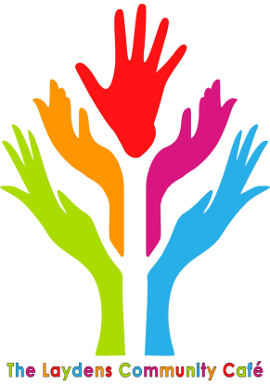
The Laydens is a thriving community café in Langley Avenue, Felixstowe. The building was donated to the Community Project: ABLE(Felixstowe) by SCDC in 2012 and was Felixstowe’s former WRVS kitchen. It needed considerable alterations before it was officially opened in 2013. Since then, there have been considerable improvements to the whole building, mainly financed through enabling grants from local councillors for which we have been very grateful. It is now a bright and welcoming café, with a modern kitchen with a Hygiene Rating of 5. It is open 9 – 3 Monday – Friday.
Our main aim is to provide inexpensive refreshments and meals and be a meeting place for residents who live in this relatively deprived area of Felixstowe. It is staffed mainly by volunteers, and it has helped many of them to move into employment. It aims to reduce mental ill-health through opportunities to meet people at the café, particularly the Parish Nurses; support people with physical and learning disabilities as all are made welcome; reduce social isolation with the help of real value-for-money nourishing meals with no time limit on staying; and to encourage people to look out for, and after, themselves and others.

