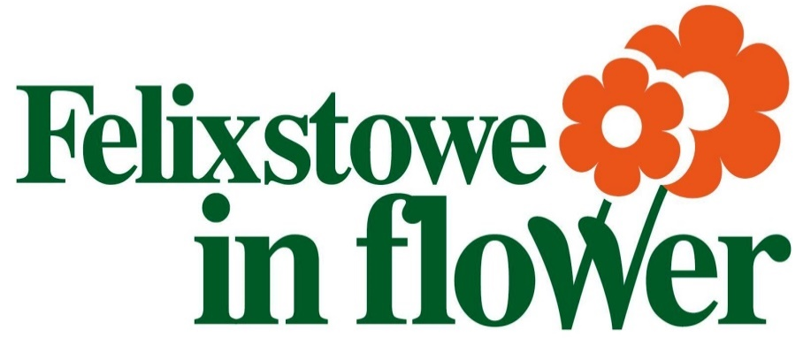
Winners 2019

School Competitions
Presented by Tanya (East of England Co-op):

1. Nursery School Competition – Gro-Bag
David Rowe Trophy
Runners Up | The Oaks Nursery
 | Felixstowe Nursery
Winner | Fairfield Nursery
2. Nursery School – Project
Alan Barker Trophy
Runners Up | Felixstowe Nursery
Winner | Fairfield Nursery
3. School’s Gro-Bag Competition (Shield)
Runners Up | Fairfield Infants
 | Colneis Junior School
Winner | Kingsfleet Primary
4. School’s Environmental Project
Port of Felixstowe Trophy
Runners Up | Colneis School
Winner | Fairfield Infants
5. Tallest Sunflower Competition
J & C Webb Trophy, Sponsored by J & C Webb
Runners Up | Jessica Ellis | 8’ 9” (2.67m)
 | Lauren Robinson | 8’ 10” (2.7m)
Winner | Thomas Barber | 11’ 3” (3.4m)

Painting Competitions
Presented by Councillor Mike Deacon & Mrs Anne Deacon

6. Nursery
Highly Commended | Everly Wishart | Fairfield Nursery
Runners Up | Amelia-Rose Harvey | Fairfield Nursery
 | Liliana Malapeau | Fairfield Nursery
Winner | Dea Gjoka | Fairfield Nursery

6. Infants
Highly Commended | Sofia Briscan | Fairfield Infant
Runners Up | Riley Graves | Fairfield Infant
 | Harvey Salmon | Fairfield Infant
Winner | Ava Macleod | Fairfield Infant

6. Juniors
Highly Commended | Nikola Ceranowska | Causton Junior
Runners Up | Olivia Wallis | Causton Junior
 | Billy Heath | Causton Junior
Winner | Amy Cook | Causton Junior

7. Commercial without Garden
Trinity College Cup, presented by The Mayor, sponsored by Trinity College
Runners Up | Gulliver’s Wife
 | Stressless Health & Beauty (Becky & Amanda)
Winner | Felixstowe Bowls Club
8. Commercial Best Container
British Fermentation Cup, presented by The Mayor
Runners Up | Felixstowe Ferry Golf Club
 | Peewit Caravan Park
 | Stressless Health & Beauty (Becky & Amanda)
Winner | Harvest Court
9. Cowpasture Allotment Competition
Cowpasture Trophy, presented by Maurice Barber & sponsored by Felixstowe Society of Allotment & Leisure Gardeners
Runners Up | Mr M Smith
 | Mr Smith-Howell
Winner | Mr H May
10. Hotel & Guest House
Chamber of Trade & Commerce Cup, presented by Roger Abbott, Chairman and sponsored by Felixstowe Chamber of Trade & Commerce
Winner | The Orwell Hotel
11. Commercial with Garden
Trinity College Trophy, presented by The Mayor, sponsored by Trinity College
Runners Up | Foxgrove + Maynell House
 | Peewit Caravan Park
 | The Half Moon
Winner | Harvest Court
12. Public House
Presented by The Mayor
Runners Up | The Half Moon (Not attending)
Winner | The Grosvenor

13. Best Sustainable Bedding
Hills the Jewellers Trophy, presented and sponsored by Paul Harris-Magri
Runners Up | Harvest Court
 | Mr D Markham & Mr R Mallet
Winner | Adrian Hine
14. Town Centre – Best Private Container
John & Angel Goodwin Trophy, presented by Angel Goodwin and sponsored by Councillor John Goodwin & Angel Goodwin
Winner | Eileen Goodwin
15. Residential Home (Shield)
Presented by the Mayor
Runners Up | Foxgrove + Maynell House
 | Harvest Court
Winner | Mill Lane Nursing Home
16. Most Unusual Container
Doreen Savage Award, presented and sponsored by Councillor Doreen Savage
Runners Up | Mr D Markham & Mr R Mallet
 | Ralph Fawkes
Winner | Foxgrove + Maynell House
17. Small Private Garden
Hotel Elizabeth Orwell Trophy, presented by Laura Horne and sponsored by Elizabeth Orwell Hotel
Runners Up | Eileen Goodwin
 | Adrian Hine
Winner | Mr D Markham & Mr R Mallet
18. Best Use of Colour
The Garfield Cup, presented by Councillor Jon & Jan Garfield
Runners Up | Diane Elmes
 | Eileen Goodwin
Winner | Mr D Markham & Mr R Mallet
19. Private Best Container
Winifred Williams Trophy, presented by The Mayor
Runners Up | Eileen Goodwin
 | Harvest Court
 | Nikki Old
Winner | Ralph Fawkes
20. Large Private Garden
Port of Felixstowe Trophy
Runners Up | Foxgrove + Maynell House
 | The Bartlet
Winner | Diane Elmes

21. Allotment Competition
The Cecil Farrow Trophy, presented by Maurice Barber and sponsored by Felixstowe Society of Allotment and Leisure Gardeners
Runner Up | Mr R Relton
Winner | Mr H May
22. Town Centre Garden Competition
Silver Salver Town Centre Residents Trophy, presented by Mr Titchener and sponsored by Felixstowe Town Centre Residents’ Association
Winner | Mrs Sandra Sparrow
23. Floral Balcony
Mike Ninnmey Trophy, presented by The Mayor and sponsored by Mike Ninnmey
Runners Up | Mr & Mrs Spooner
 | Harvest Court
Winner | Mr D Markham & Mr R Mallet
24. Seaside Theme
Mrs Melody Gordon Trophy, presented and sponsored by Melody Gordon
Runners Up | Foxgrove + Maynell House
 | Peewit Caravan Park
Winner | Adrian Hine
25. Best New Entry – Allotment Competition
Julian Sage Trophy
Winner | Ms Jane Foley
26. Best New Entry
Ann Rodwell Trophy, presented and sponsored by Gordon Rodwell
Winner | Eileen Goodwin
27. Best of the Best
Don Smith Trophy, presented by The Mayor and sponsored by Don Smith
Winner | Mr D Markham & Mr R Mallet

Special thanks to…
East of England Funeral Services
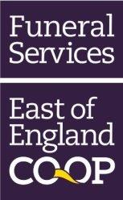

Our main sponsors this year

Our judges:

Jan Carlton | Gardens
Sally Gallant
Carol Wallace
Tanya Carlton-Smith | Schools
Sharon Harkin
Sue Faversham
Heather Prince | Paintings
Karen Kenny | Allotments
Sarah Meehan

1st Old Felixstowe Guides

And our amazing photographer Chris Carne

